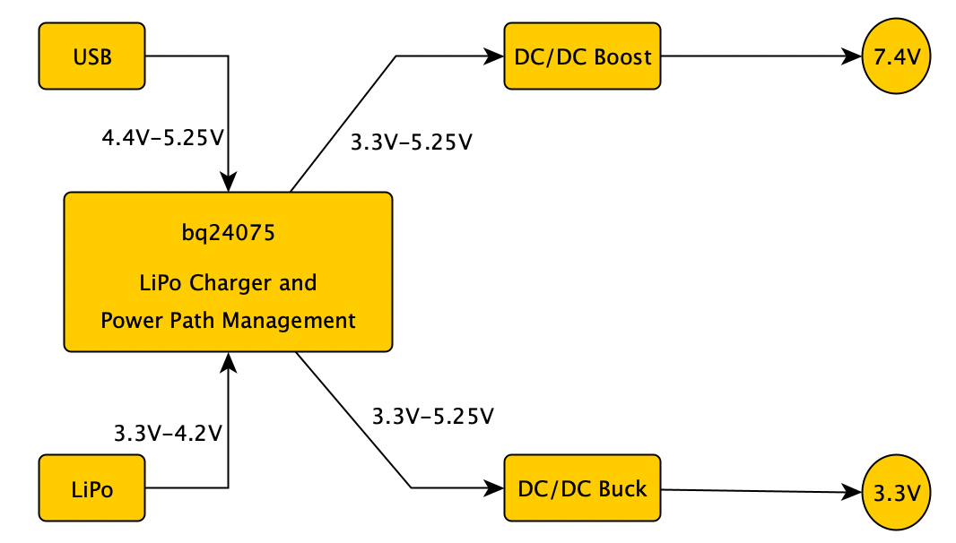

**Boost Circuit 1 (7.4V)**

Input voltage range: 3.3 - 5.25V

Output voltage: 7.4V

Output current: 1.5A

Schematic:

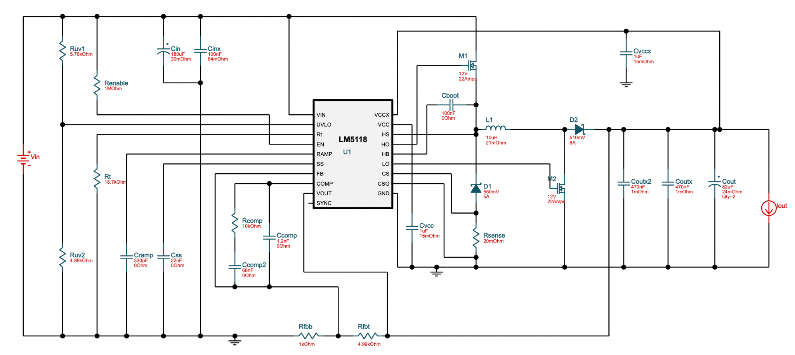

**Buck Circuit 2 (3.3V)**

Input voltage range: 3.3 - 5.25V

Output voltage: 3.3V

Output current: 1A

Schematic:

